Scoil Bhríde, Cill Bhríde  Clonee, Co. Meath.  Telephone/Fax: 01-8216359/01-8220593  Email: info@scoilbhridens.ie  Web: http://www.scoilbhridens.ie  Roll No: 168250 | 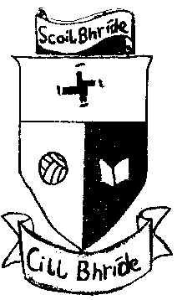

COVID-19 Policy Statement
Scoil Bhride is committed to providing a safe and healthy workplace for all our staff and a safe learning environment for all our pupils. To ensure that, we have developed the following COVID-19 Response Plan. The BOM and all school staff are responsible for the implementation of this plan and a combined effort will help contain the spread of the virus. We will:
- continue to monitor our COVID-19 response and amend this plan in consultation with our staff
- provide up to date information to our staff and pupils on the Public Health advice issued by the HSE and Gov.ie
- display information on the signs and symptoms of COVID-19 and correct handwashing techniques
- agree with staff, a worker representative who is easily identifiable to carry out the role outlined in this plan
- inform all staff and pupils of essential hygiene and respiratory etiquette and physical distancing requirements
- adapt the school to facilitate physical distancing as appropriate in line with the guidance and direction of the Department of Education
- keep a contact log to help with contact tracing
- ensure staff engage with the induction / familiarisation briefing provided by the Department of Education
- implement the agreed procedures to be followed in the event of someone showing symptoms of COVID-19 while at school
- provide instructions for staff and pupils to follow if they develop signs and symptoms of COVID-19 during school time
- implement cleaning in line with Department of Education advice
The above will be reviewed and updated as required in line with HSE advice and guidance.

